2-3 Renewable Energy Engineers
Week 1: Energy and All It’s Types
A) BIG IDEA or CONCEPTS-LEARNING OBJECTIVES (3 points)
Goal Statement/Objectives: Students will be able to describe how energy can come in two forms renewable and nonrenewable energy. Students will be able to demonstrate their understanding of renewable and nonrenewable by accurately contribute to the whole class discussion.

Kid Language: What are the two types of energy? What are the similarities and differences between these two types of energy? (renewable and nonrenewable energy)

B) STANDARDS (4 points)
Content Standards:
4.ESS.2 Obtain and combine information to describe that energy and fuels are derived from natural resources and their uses affect the environment.
Process Standards:
SEPS.2 Developing and using models and tools
SEPS.3 Constructing and performing investigations
SEPS.6 Constructing explanations (for science) and designing solutions (for engineering)

C) MATERIALS (4 points)
- 8 different construction paper- span of light to dark (30 each)
- Stapler, thermometers - 7
- Flashlight, Glass jars- 9
- White paper- 30
- Piece of clear plastic- 30
- Cardboard
- Aluminum foil
- Wax paper
- Tissue paper
- Water, Mirror- 9
- Cloth, Hand lens- 9
- Paper plates- 9
- Red, yellow, white paper- 30
- Plastic cup- 30 (5 oz)
- String-30
- Paper clip-30
- Scissors- 9
- Glue- 9
- *Pushpin- 9- we will address the safety concern by having the teachers make holes in the bottom of the cups with the pushpins prior to the lesson so the students are not using them by themselves.

D) TEACHER CONTENT KNOWLEDGE (4 points)

For this lesson we are giving a general introduction about energy. The content knowledge the teachers should know to complete this lesson are the different types of energy (e.g. sound, light, heat, nonrenewable, renewable), how we get them, and what are alternatives to nonrenewable. We will be introducing each type of energies through activities, videos, and discussions. Potential misconceptions that can occur in the lesson are: students not knowing the different forms of energy or thinking light, sound, and heat are types of energy.. To address this misconceptions we will have activities to demonstrate how and why light, sound, and heat are energies.

E) REFERENCES & HANDOUTS (2 point)

Read Aloud: Energy Makes Things Happen
Videos: What is Energy- https://www.youtube.com/watch?v=NKJifzlOSoQ
Renewable and NonRenewable Resources- https://www.youtube.com/watch?v=pBTnVoEIb98

Station Activities: Energy Explorations: Sound, Light, and Heat by AIMS Education Foundation
- Crowing Cups (construction): Melissa and Ike (Sound Energy, p. 39)
- Just passing Through: Alex & Shannon (Light Energy p. 109)
- Solar Mitts: outside Kristen and Lindsey (Heat Energy p. 197)

Small Group Discussions:
  - Natural gas/Fracking-
    - Video: https://youtu.be/-njmj0diWu8
    - Website: http://www.eia.gov/kids/energy.cfm?page=natural_gas_home-basics
  - Coal Mining-
    - Video: http://www.sciencechannel.com/tv-shows/how-do-they-do-it/videos/how-do-they-do-it-coal-mining/
    - Website: http://www.eia.gov/KIDS/energy.cfm?page=coal_home-basics
      - http://wiki.kidzsearch.com/wiki/Coal_mining
  - Oil ocean drilling
    - Videos
      - https://www.youtube.com/watch?v=xZ1HIBIIJU0
      - https://www.youtube.com/watch?v=A0XvAdwFW8Q 1:30-2:15
    - Images
      - https://www.google.com/search?q=oil+spill&source=lnms&tbm=isch&sa=X&ved=0ahUKEwiv69_dh9jPAhVMFj4KHVVuD1YQ_AUICSgC&biw=1158&bih=643#imgrc=Gn148fPAw85TgM%3A
      - https://www.google.com/search?q=oil+spill&source=lnms&tbm=isch&sa=X&ved=0ahUKEwiv69_dh9jPAhVMFj4KHVVuD1YQ_AUICSgC&biw=1158&bih=643#tbm=isch&q=oil+rig+explosion&imgrc=quByHv6UifuukM%3A
    - Prezi
      - http://prezi.com/cnnt6zksp2nf/?utm_campaign=share&utm_medium=copy
  - Nuclear Energy:
    - Video - https://youtu.be/91XW8AkjG2Y
    - Website - http://www.softschools.com/examples/science/nuclear_energy_examples/164/

F) TENTATIVE TIMELINE (5pts)
9:30-9:45 Introduction, Read aloud: “Energy Makes Things Happen”
9:45-9:50 Video and quick connection conversation (making a T-Chart for the students to reference)- What is Energy? https://www.youtube.com/watch?v=NKJifzlOSoQ
9:50-10:35 Stations (3)
Crowing Cups (construction): Melissa and Ike (Sound Energy, p. 39)
Just passing Through: Alex & Shannon (Light Energy p. 109)
Solar Mitts: outside Kristen and Lindsey (Heat Energy p. 197)
10:35-10:50 Bathroom and Snack
10:50-11:05 Outside Running Activity (foods ate at snack is turned into chemical energy which transfers to working/kinetic/physical energy while running)
11:05-12:00
- Video: https://www.youtube.com/watch?v=pBTnVoEIb98
- Fill out the KW in the KWL chart over Renewable v. Nonrenewable resource
- 10 - 15 mins 5 Small Group Discussion Where does our RENEWABLE energy come from? - Have the students come up with one or two bullets for the L section of the KWL Chart (Melissa and Ike are facilitators)
  - Natural gas/Fracking- Alex
  - Coal Mining- Lindsey
  - Oil ocean drilling-Shannon
  - Nuclear Energy: Kristen
- Add to the L section in the KWL chart over renewable v. nonrenewable resource (we will be adding to this section every week) What are some alternatives?

Time Filler (activities for students who are bored):
- Vocabulary Review Worksheet- crossword puzzle *When students come in from outside
- Coloring pages

F) DESCRIPTION OF YOUR LESSON (8 points)
ENGAGE
Energy Lesson:
To engage the students in this lesson we will conduct a read aloud over “Energy Makes Things Happen”. This read aloud will give the students an idea about what energy is and will start getting them thinking about how energy works.
Read aloud questions for discussion are:
- What types of energy do you use in your daily life?
- How do you know it is a form of energy?
- What activity do you do that uses the most energy?
After the read aloud the students will watch a short clip. This video clip will engage the students even more over the topics of “What energy is?” The purpose is to put the students even further in the mindset of thinking about the energy they will soon be investigating.
Some questions that we will ask them to assess them are:
- Where have you seen energy?
- What types of energy have you heard of?

Nonrenewable and Renewable Energy Lesson:
Once we come back from our outside activity we will re-engage and redirect the students’ attention to two specific categories of energy: Nonrenewable and Renewable Energy. We will do this by having the students watch another video- Stop Motion Film: Renewable vs NonRenewable Energy Sources. This video deals with the two different types of energy and will engage the students because they are learning about the topics.
After the video we will conduct a KWL chart over Nonrenewable vs. Renewable Energy. Here we will be filling out the KW sections of the chart. This will engage the students by refocus their minds and share their insights with one another over the topic we are studying. The W section also allows the students to think about what they want to know and preparing them to investigate in a way to answer their own questions.
Some questions that we will ask them to assess them are:
- What is the difference between nonrenewable and renewable?
- Do you think that you use more renewable or nonrenewable resources throughout your day?
- What do you want to learn about energy?
- What are some kinds of renewable energy you have heard of?
EXPLORE
Energy Lesson:
The opportunities provided for the students will be done in stations: Constructing Crowing Cups;
Just Passing Through; and Solar Mitts. These stations will allow for the students to explore three different types of energy (sound, light, and heat) through the completion and construction of the station activities. In the first station the students are going to have the students explore crowing cups. In this they are exploring how energy is transferred in the cup and the string. The second station has to do with light transparency. This will have to do with students exploring how light energy works and transfers through objects. Finally, our last station has to do with heat energy, having the students create solar mittens, one black and one white. At this station they will explore how solar energy works when the mittens produce heat.
After snack the students will be going outside to participate in a running game. Here the students are to investigate how we get energy from food.
Assessment questions in each station:
- Where do we see energy in this activity?
- What type of energy is it?

Nonrenewable and Renewable Energy Lesson:
After filling out the KW chart over nonrenewable and renewable chart the students will break out into four groups, investigating - Where does our energy come from? Each group will be exploring on the internet, searching on a nonrenewable research (natural gas/ fracking; coal/mining; oil/ocean drilling; nuclear energy).
Assessment questions:
- How do we get _________ energy for us to use?
- What is nonrenewable resource?
- What is renewable resource?
EXPLAIN
Energy Lesson:
We provide the students an opportunity to explain their previous experiences with energy in terms of what it is and the types it some in through the T-chart we will be filling out during the engage and explore sections of the lesson. In addition they will be explaining in their station groups how the activities exhibits sound, light, and heat energy. The students will have to use their previous experiences to describe the science phenomenon.
Some questions that we will ask them to assess them are:
- How does the crowing cups demonstrate sound energy?
- How does the sound mittens demonstrate heat energy?
- How does the light transmitting activity demonstrate light energy?

Nonrenewable and Renewable Energy Lesson:
We provide the students an opportunity to explain their previous experiences with energy in the KWL chart. They have an opportunity to share their knowledge on the subject right at the beginning of the lesson so that we can see where they are at with this topic. Also, in the learned part the students can start to use scientific terms in what they learned from what we explained to them throughout the lesson. Specifically, after conducting research the students will share their findings in a whole group discussion. As they share their discovery they will build on their L section of the KWL chart.
Some questions that we will ask them in this for assessment are:
- What have you learned about your nonrenewable energy?
- Have you seen any of these types of energy, if yes where?
ELABORATION:
Energy Lesson and Nonrenewable and Renewable Energy Lesson:
At the end of the lesson the students will be doing a discussion that will be an elaboration of what they learned. This will help the students to apply and extend their thinking because they are going to be building off of what they learned in the lesson about renewable energy and writing and creating ideas about what they believe are good and bad forms of energy. It is elaborating on what they learned because it helps them put their own ideas down on paper and recap the information that they learned.
Some questions we will ask them in this for assessment are:
- What are some types of energy? (heat, light, sound, chemical, physical)
- What are some examples of nonrenewable energy?

G) EMBEDDED FORMATIVE ASSESSMENT (also part of the 5th “E”) (3 points)
We will be asking the students assessment questions throughout each phase of the lesson, which are embedded in our four E’s. At the end of the activity we will be providing the students with a discussion activity that will give us further information about how much the students are understanding about energy.

H) GEARING UP/GEARING DOWN (2 point)
Gearing up – To gear this lesson up there will be challenger questions to make the students think deeper over the topic. For example: What are some other types of sound energy you see daily? How does it make noise? What other ways provide evidence of the (crow cups/light/solar mittens) having energy? Can the energy transform into a different type? In addition to the questions at the three stations, we will have the students completed a review sheet waiting for them to do while others work. This worksheet will review the vocabulary that they just learned and will give them a further idea about how energy works and how they can spot energy around them.

Gearing down – To gear this lesson down we will have the helpers ask them questions to help them make connections and simplify the topic. Each helper will have a list of questions to help the students. This will give the students a chance to look at the question that is being asked in different ways to further help them understand the concepts that are being discussed.

Vocab Sheet:
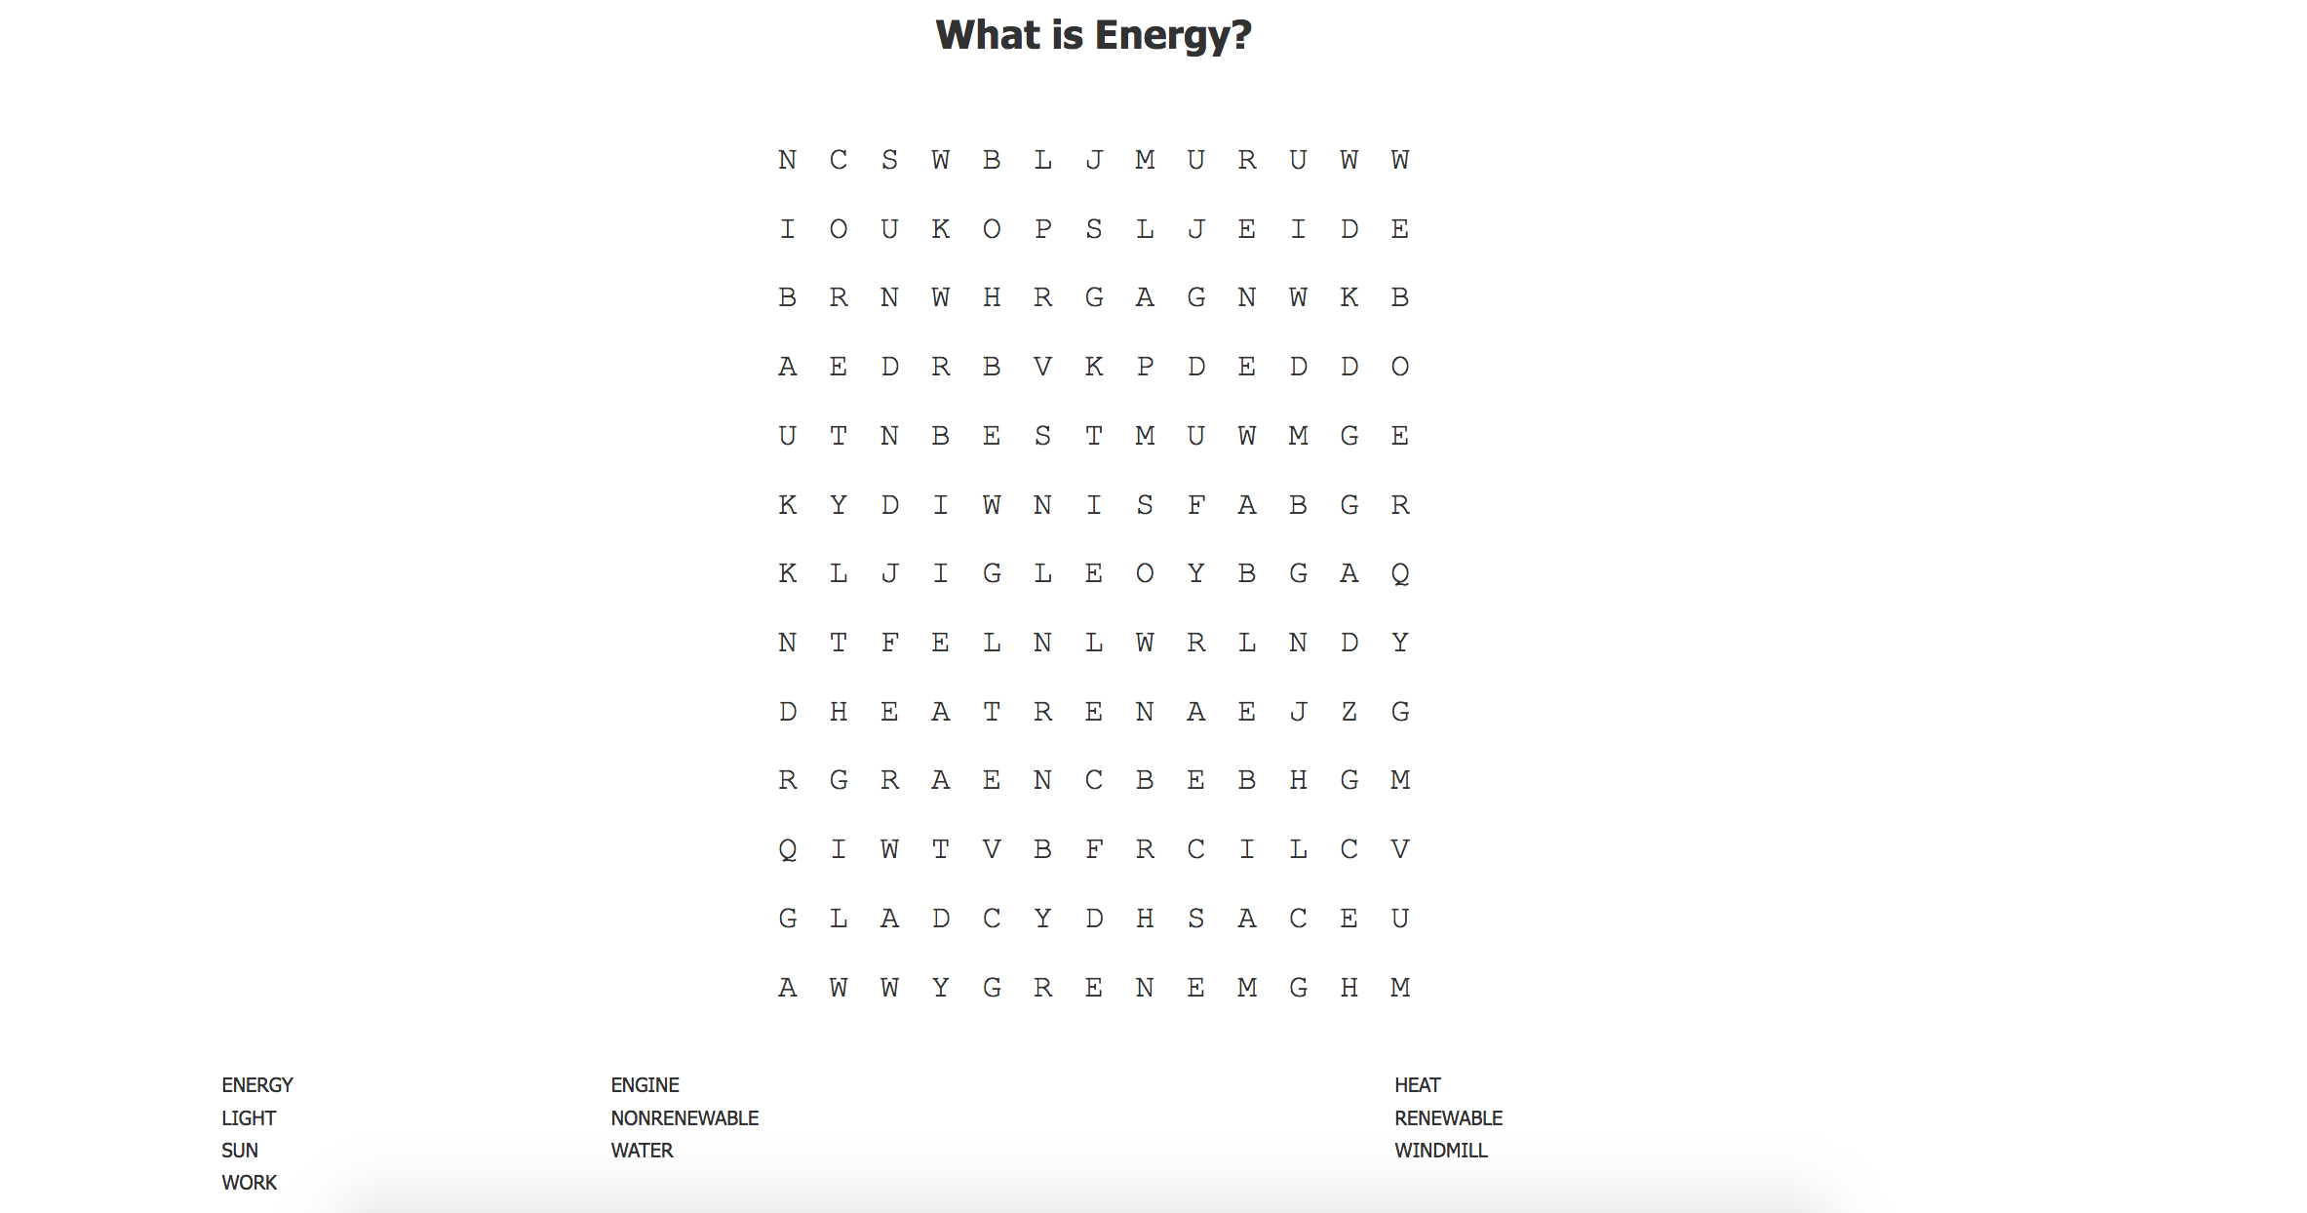

Week 2: Solar Power Second and Third grade

A) BIG IDEA or CONCEPTS-LEARNING OBJECTIVES (3 points)
· Write the sentences in kid language – meaning these sentences should be something that you expect your students to be able to say or write by the end of the lesson.

Goal Statement: Students will be able to understand how energy from the sun can be used for human need. Students will demonstrate this by building their own solar ovens and by accurately filling out their journal entry explaining how the oven cooked the s’mores.

Focus Question: How can the sun be used as a source of energy?

B) Content Standards: (4 points)
4.PS.4 Describe and investigate the different ways in which energy can be generated and/or converted from one form of energy to another form of energy.
4.PS.5 Make observations to provide evidence that energy can be transferred from place to place by sound, light, heat, and electric currents.
Process Standards:
SEPS.2: Developing and using models and tools
SEPS.3: Constructing and performing investigations
SEPS.6: Constructing explanations (for science) and designing solutions (for engineering)

C) MATERIALS (4 points) Submit on Wednesday
5 rolls Masking tape, glue, etc.
5 Thermometers
5 Timers (stopwatch ok)
6 Cardboard box- pizza box size
6 Aluminum pans- small enough to fit in the shoe box
5 rolls Aluminum foil
6 pieces Black construction paper
5 rolls of plastic wrap or large ziplock bags
6 Newspapers
6 rulers
Six Sunshine OR gooseneck
lamp with 100-Watt bulb
S ‘mores fixings (graham crackers, marshmallows,
and chocolate) enough for 25
Oven mitts

D) TEACHER CONTENT KNOWLEDGE (4 points)
The content focus of this lesson plan is the renewable energy source found in the sun (solar energy). Things the teachers should understand are:
- Definitions
  - Solar Energy: Radiant energy emitted by the sun
  - Nonrenewable resource: Any natural resource from the Earth that exists in limited supply and cannot be replaced if it is used up; also, any natural resource that cannot be replenished by natural means at the same rates that it is consumed
  - Renewable resource:A substance of economic value that can be replaced or replenished in the same or less amount of time as it takes to draw the supply down.
- Solar power provides energy harnessed from the sun that can be converted to electrical or thermal energy.
- A pro to solar energy is that it is one of the cleanest and best forms of renewable energy that is available to be used.
- Many people have switched to solar panels to cut down on the cost of electricity, both lighting and heat.
- There is more than one way in order to access and use solar energy: photovoltaics (also called solar electric), solar heating & cooling, concentrating solar power (typically built at utility-scale), and passive solar
- Using solar energy is efficient and useful, but the current concern is the high cost of manufacturing solar equipment.
Possible misconceptions:

Solar power can only be used in warmer climates.
  - Temperature has no effect on solar panels and the amount of power generated. Solar panels are in fact a little more efficient at energy production in cooler temperatures. The amount of sunlight that solar cells receive, which is termed as solar insolation, is the main factor. Accordingly, even northerly situated states and countries will receive enough sunlight for solar panels to work effectively. Currently, the world leader for solar photovoltaic energy is not a country reputed for particularly sunny skies, and that is Germany.
- After installing solar panels a back-up generator is required.
  - The vast majority of homes that have solar power energy plants installed are connected to the electric grid. This allows for your home to be powered and any extra electricity to be fed back to the grid, which in effect actually turns your electric meter backwards. However, even during the night, or on very cloudy days, you can still rely on electricity being provided by your local provider, as long as you install a grid-tie solar system, grid-ties being the most commonly available systems.
- Using solar power means you can’t use modern conveniences.
  - Again, because your home will always remain connected to your local solar energy power supplier, you can use modern home conveniences at will, no matter how extreme their power consumption, although most modern appliances are extremely power friendly with ever-better standards being introduced on a regular basis.

Because solar power is overly expensive, it’s not suitable for mass consumption.

Billions of dollars of solar power research and a large amount of technological progress over decades are now resulting in reliable production and greatly reduced pricing. Further, due to governmental (both federal and state) as well as utility company backing, programs are now available which are suited and affordable to almost any homeowner or business. A home-based solar system can provide 26 to 29 years of pollution-free electricity before it’s necessary for a replacement installation.

The use of solar panels is environmentally unfriendly.
  - A report compiled by the National Renewable Energy Lab found that the energy used to produce solar photovoltaic panels is paid back within one to four years, dependent on the amount of solar insolation which is available within your area and the type of panel used. Typically, solar panels last for 25 to 30 years, which means that net energy savings over and above other energy resources which are fossil-based is vast. What’s more, at the end of a solar panel’s life, the installer may offer to recycle the components.
- Use of Solar Energy Means Compromised Life Quality
  - After installing solar systems, homes still stay on-grid and the generated energy can offset part of energy need from the grid. As a result, power supply is stable enough to support regular demand while saving on energy consumption. Users do not necessarily have to trade inconvenience for eco-friendliness.

E) REFERENCES & HANDOUTS (2 point)
- Videos:
  - Magic School Bus Video: https://www.youtube.com/watch?v=CtIdER7UkzQ&list=PLWEVvZtBqsJ_fBp_Eok9r-Mm6UBOGq2zp
  - Bill Nye Video: https://www.youtube.com/watch?v=av24fEMhDoU
  - Solar Energy Video: https://www.youtube.com/watch?v=NDZzAIcCQLQ
- Solar Oven: http://www.nasa.gov/pdf/544871main_E3_SolarOven_C4.pdf
- Science Journal: Located at bottom of the lesson
- Addressing misconceptions:
  - http://www.solarsystemsma.com/solar-power-misconceptions.php

F) TENTATIVE TIMELINE (5pts)
(Lead Teachers are Shannon and Alex; Supporting Teachers are Ike, Melissa, Kristen, Lindsey)

9:30- 9:35 Introduce an attention getter and go over the kicking and spinning on chairs
Review of renewable and nonrenewable energy, Shannon and Alex are leading this
- Review the KWL Chart
- Write down the definitions to nonrenewable and renewable on board and have students copy in their journal
9:35- 9:42 Read aloud: “Solar Energy”- only some parts, not the whole thing, Shannon is conducting the read aloud
9:42- 9:52 Water Bottles and Balloons, Shannon and Alex are leading this
- The whole class will travel outside (weather permitting). One bottle will be painted white, and the other black; each will have a balloon over the opening. We will take the students outside to put the water bottles in the sun and will revisit them at the end of the lesson. As the water bottles sit out in the sun, or in front of a heat lamp, the water should start to evaporate. The black water bottle balloon should fill up faster in the sun than the clear water bottle because the black paper absorbs the solar energy, making the temperature of the water higher compared to the clear water bottle.
  - If the sun is not out and working we will be using the lights found in the classroom to replicate the experiment.
9:52- 10:00 Solar Energy Tag Game, Alex is leading this

10:00- 10:45 Go back inside and begin the solar oven activity. All teachers will walk around and help
- For this activity students will be making their own solar oven. Here they have the option to create their ovens in pairs or individually. The students will be given all materials needed to create the ovens, but without any instruction. The goal is for this activity to be completely investigation based.
10:45-10:55 Read Chapter 7 and 8 of “Solar Energy”, Shannon will conduct this

10:55- 11:15 Snack while watching Magic School Bus Video: https://www.youtube.com/watch?v=CtIdER7UkzQ&list=PLWEVvZtBqsJ_fBp_Eok9r-Mm6UBOGq2zp

11:15-11:30 Revisit our water bottle and balloons activity, Shannon and Alex will lead this

11:30-11:45 Bring the students back to a whole class discussion (Shannon and Alex will lead this):
- Results of Water Bottles and Balloons
- Results of Solar Oven
- What are the Pros and Cons of Solar Energy (Creating a T-Chart)
11:45-12:00 Journal Entry: Students will fill out their Science Journal to recap what has been learned, All teachers will walk around and help
Have the students write their own definition and examples, then ask for examples to write on the board. What the students will be filling out in their journals.
  - Definition of Solar Energy
  - Examples of solar energy
  - Pros vs. Cons of solar energy

F) DESCRIPTION OF YOUR LESSON (8 points)
· Follow a 5E learning cycle model of instruction to guide your lesson plan. In the four sections below describe what you will be doing (the teacher’s role) and what your students will be doing (the students’ role) for each section/activity. Be VERY clear with your descriptions, but write them in a way that you can easily refer to them if you need to (e.g., use bullet points). Note- you may not have separate activities that fall under each of the four sections but you should explain how you will address the other phases embedded within the activities you are doing.
ENGAGE

We will engage the students initially by reviewing renewable and nonrenewable resource, KWL chart, from week one. This will refresh the student’s memories of the terms and will allow all students to participate.
Some questions that we will ask them to assess their retained knowledge are:
- What is the difference between nonrenewable and renewable energy?
- Do you think that you use more renewable or nonrenewable resources throughout your day?
- What are some kinds of renewable energy you have heard of?
- What did you learn learn about the two forms of energy?

Our group has prepared journals for each individual student to keep definitions of significant terms. The students will write down the definitions of renewable and nonrenewable resources in their journals.

Read aloud: To engage the students in this lesson we will conduct a read aloud over “Fueling The Future, Solar Energy.” The read aloud will give the students an idea about what solar energy is and will enable them to understand how and why it works.
Read aloud questions for discussion are:
- What types of solar energy are used in your daily life?
- How do you know it is a form of energy?
- What activities require the most solar energy, the least?
EXPLORE

To get the students to explore we will introduce the water bottle investigation activity. This will be pre-made; one water bottle will be painted black and the other white, both will be filled with water, and both will have balloons covering their openings. We will take the kids outside and have them make predictions about what will happen to each when the sun is shining on them. We will leave them outside and revisit later.
Some questions we will ask them during this activity are:
- Which balloon will you think will fill up with air first?
- Which water bottle do you think will be warmer at the end of this investigation?
- Why do you think one water bottle attracts more heat over the other one?

While we are outside, we will play a quick game of Solar Energy Tag. Two of the kids will be taggers, and two will have flashlights and be “melters”. When a kid gets tagged, he or she must freeze until a melter shines them with a flashlight and melts them. They may then run around and join back in the game.
Some questions we will ask the students after they are done playing the game are:
- Why does light/ the sun make things melt?
- Once a substance is melted, how can it turn into a gas/ vapor?
- What does solar energy have to do with this game?

After tag, we will go back inside and begin the solar oven activity. We will begin by discussing what should happen in a solar oven, and what materials can be used. The students will be given many different materials, and will be challenged to create their own design. They may work in groups or individually. We will have lamps set up around the room so students are able to go and test their ovens and make changes as needed. The main focus of this is the design, not whether or not the ovens actually work. Teachers will be walking around and providing guidance as needed.
Some questions we will ask the students during this activity are:
- Why did you choose that design for your oven?
- How do you think the solar ovens work?
- How long do you think it would take to cook your marshmallow using your solar oven?

EXPLAIN
Once everyone has created their solar ovens, we will discuss the different materials we used in the solar ovens what makes the most effective oven. We will also revisit the water bottle activity and discuss as a class what happened and why. Teachers should be guiding students through these discussions.
Questions we will ask regarding the water bottles are:
- Were your predictions right about what balloon filled up with air first?
- Were your predictions right about which water bottle became hotter?
We will also explain how one balloon was able to fill up with air faster and why one water bottle was hotter. We can then connect this to the solar ovens that the students created because it both cases black (paper/ paint) was used to absorb solar energy to make the black water bottle and the solar oven hotter.
ELABORATION
We will create a T-chart about Solar Energy overall. We will bring in ideas from the different activities to find the pros and cons of using solar energy in everyday life. Teachers should be guiding students through this discussion.
Some potential questions will will ask are:
- Why do you think that is a pro/ con of solar energy?
- What types of resources are people using now to capture solar energy?
- How can we improve solar energy for the future?
In this section we will also be giving students a journal to fill out to go along with the T-chart. In their journals they will once again describe the pros and cons of solar energy. We will collect their journals at the end of the day and review them to make sure that the students are on the right page and understanding the content of our lesson.

G) EMBEDDED FORMATIVE ASSESSMENT (also part of the 5th “E”) (3 points)
· During a single lesson the majority of your assessment of student learning and conceptual understanding is formative in nature; meaning you are asking questions or having students write their thoughts, evidence, and explanations in science notebooks.
· Formative assessment helps you to understand how well your students are grasping the concepts you listed in the BIG IDEAS/CONCEPTS/LEARNING OBJECTIVES section of your plan.
For example, are they struggling with articulating explanations for the phenomena they are experiencing based on the evidence they have collected, are their explanations actually creating more misconceptions, or are they actually beginning to develop some real insight into developing their scientific knowledge of the concept.
· In this portion of your lesson plan I want you to refer to the prior sections of your lesson description again (i.e. engage, explore, explain, elaborate) and use those categories to organize the kinds of specific questions you will ask your students at each phase of your lesson. You may incorporate these questions into your descriptions above OR write them here, designated by the stage you will ask them in, which ever you prefer. They must be clear so I can differentiate what you will be doing from what you will saying/asking (i.e. italicize/bold).

H) GEARING UP/GEARING DOWN (2 point)
Write two brief paragraphs that describes alternatives for the lesson. Note: this section is not asking you to write a whole new lesson, nor is it asking you to consider what you will do if you run out of time or over time. Instead, it is asking you to think about the various learners in your class and how you will address the needs of all your students.
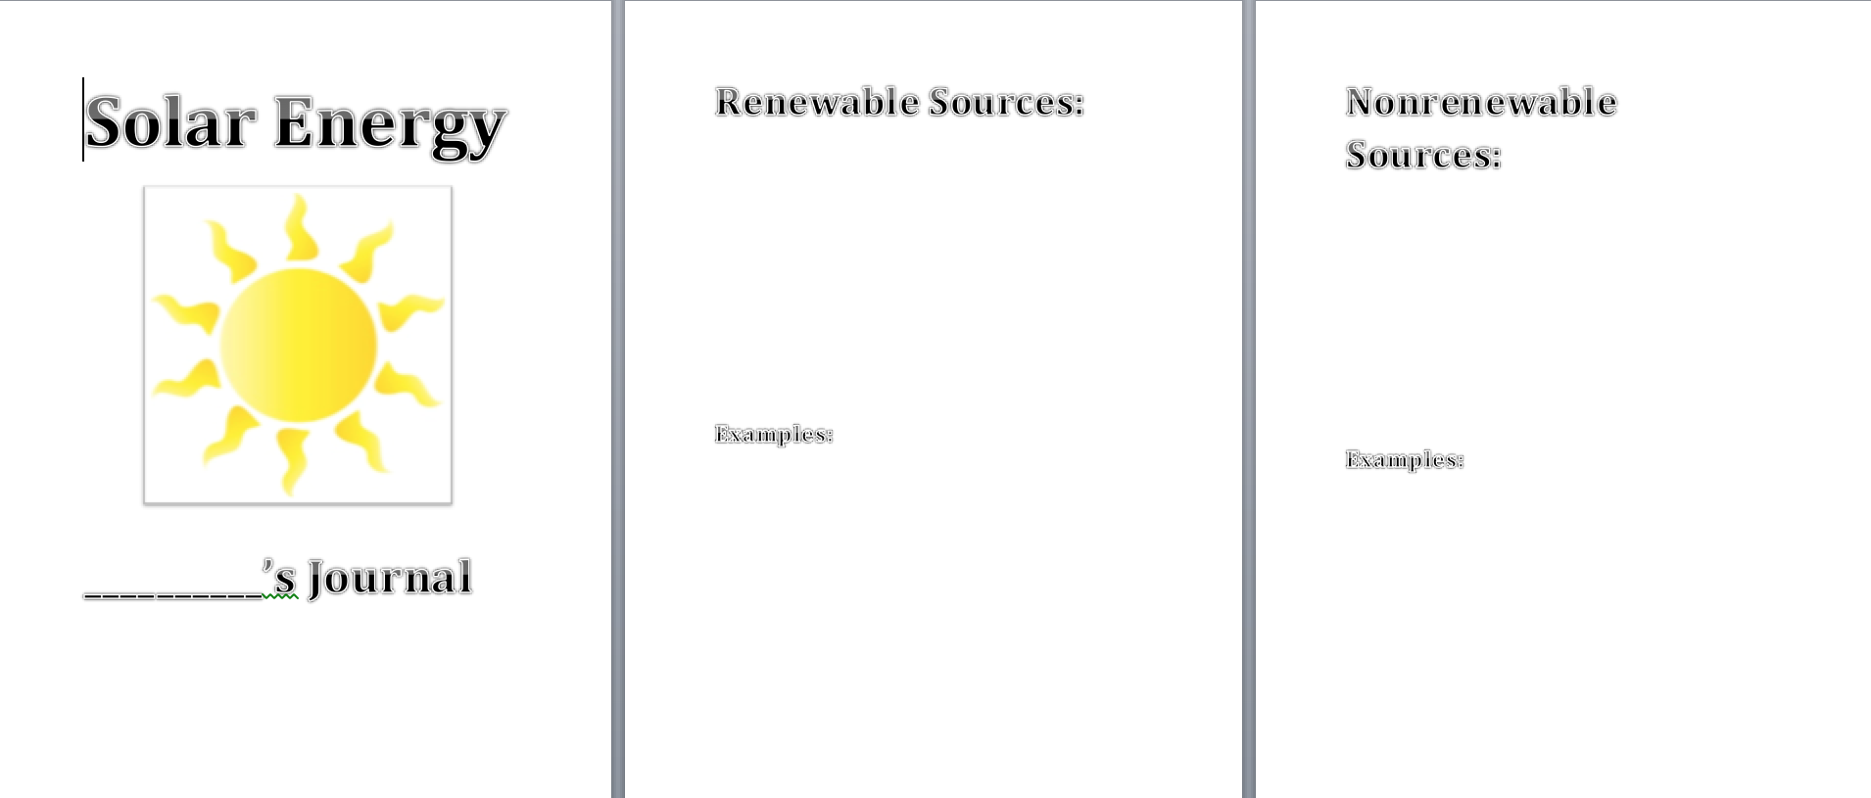
Gearing up – If students are understanding the content being taught fairly easily we will ask more challenging questions and give them more agency during the explore phase. For example, if a student finishes their design before others we may ask them if they could make the solar oven bigger or make the same thing with less materials. Some questions we may ask would be “What can we cook with this oven? or Why is light so important to us when using the ovens?”

Gearing down – To gear down the lesson, we will have some of the parts of the solar oven already done to allow for the students to have a basis of understanding on how to get started building a solar oven. If we realize the lesson has to be geared down during the lesson, we will have support teachers help the students with their understanding by working together on the project. The students will still feel like they accomplished the lesson because their solar oven will be completed, but with the help of a teacher.

Journal:

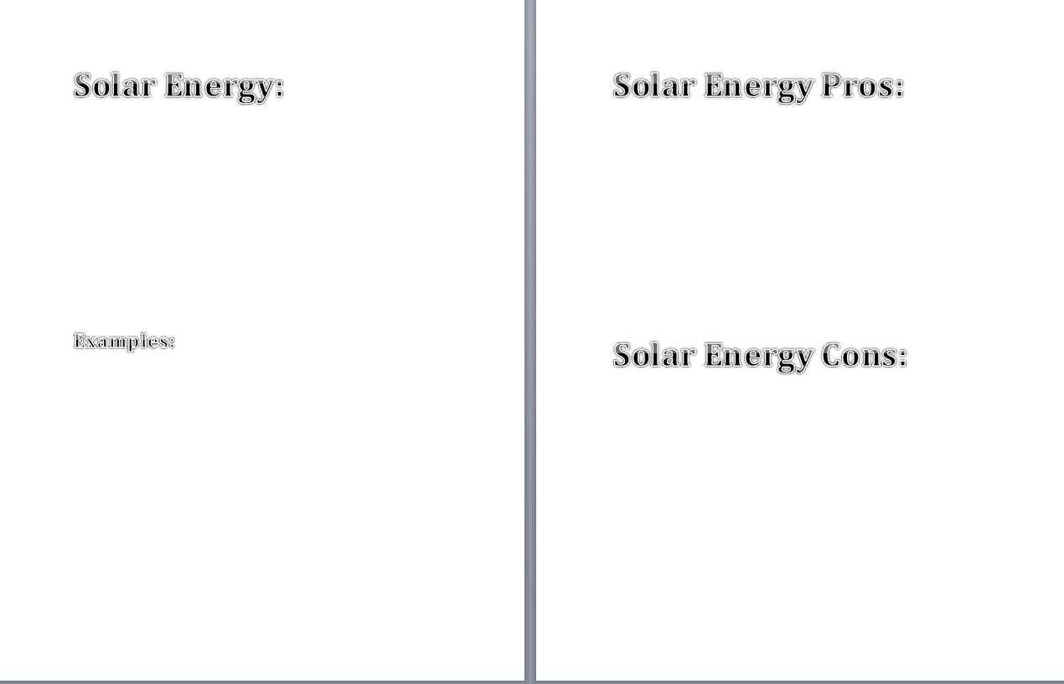

Week 3: Wind Energy Second and Third

A) BIG IDEA or CONCEPTS-LEARNING OBJECTIVES (3 points)

Goal Statement: Students will be able to demonstrate how wind can be used as a source of energy. They will do this by creating their own pinwheels and demonstrate their comprehension by filling out their Components of a Windmill worksheet, KWL chart, and accurately identifying the different parts and jobs of the windmill.

Focus Question: How can the wind be used as a source of energy?

B) STANDARDS (4 points)
4.ESS.2 Obtain and combine information to describe that energy and fuels are derived from natural resources and their uses affect the environment.
Process Standards:
SEPS.2 Developing and using models and tools
SEPS.3 Constructing and performing investigations
SEPS.6 Constructing explanations (for science) and designing solutions (for engineering)

C) MATERIALS (4 points)
*Pushpins (30) - Lindsey
Halloween Pencils (30) - Kristen
Paper towel rolls - Kristen
Foam plates for glue - 12
Markers, crayons, and pencils tubs - 6
Cups of various sizes (10 - 25 of each- these will be a base choice for the students’ pinwheels)
Large cups 16 oz -10 -25
Scissors - 12 to 18
Glue sticks - 12 to 18
Elmer’s Glue - 12 to 18
Masking tape - 6 rolls
Construction paper
Skewers- 40
Small paperclips - 6 boxes (one for each table)
Paper plates - min 25
Clay
Aluminum Foil - 2 rolls
Cardboard squares
T-Chart paper
To decorate the pinwheels:
Pipe cleaners
Pom Poms
Stickers
Fans - 3

*We will address how pushpins are only used to pin the paper and they will come to a teacher to place the pin in the base of their pinwheel.

D) TEACHER CONTENT KNOWLEDGE (4 points)
Teachers who are instructing this lesson should understand the basics of wind and how it is converted into electrical energy (Wind turns the blade =>rotates the parts inside the body of the turbine => rotates the generator => electricity). Wind energy can also be called wind power both deal with the process of using wind to generate mechanical power and or electricity. Wind turbines are the proper term and are used to generate electricity. The teacher needs to understand the components of wind turbine and their purposes:
- Rotors or Blades
  - Job is to transform the kinetic energy of the wind to rotational energy
- Generator or gearbox
  - Transforms the rotational energy into electrical energy
- Tower of shaft
  - Support structure for the blades and generator
- Other functions such as:
  - Interconnection equipment and Electrical cables - allow and transfers the electrical flow or current to the places it needs to go
  - Ground support equipment - helps keep the tower standing
  - Controls - the speed or amount of energy conversation, on and off switched, etc.
The teacher should also understand the pros and cons to this renewable resource. The pros that come along with wind energy are how it is non-polluting and the wind is free. Cons to this energy resource are some of environmental in terms of the visual impact it has on the landscape, animals being hurt (birds, bats, butterflies being killed by flying into the rotating blades), and the sound disruption the windmills create. In addition to the environmental concerns, the placement of wind farms need to be placed in landscapes where there are is a lot of consistent wind, making them located far away from the bigger cities. This is problematic because the cities are the ones who need the energy the most and with these farms being far away it makes it difficult to transport the energy to the cities.

E) REFERENCES & HANDOUTS (2 point)
- Websites http://www.livescience.com/2890-5-myths-wind-energy.html; http://windeis.anl.gov/guide/basics/
- Read Aloud: The Boy Who Harnessed the Wind by William Kamkwamba and Bryan Mealer; Energy Island by Allan Drummond
- Videos: Energy 101: Wind Power: https://youtu.be/niZ_cvu9Fts;
- Wind Power: https://youtu.be/SQpbTTGe_gk
- Pinterest ideas: Cup Pinwheel - https://www.pinterest.com/pin/561120434807993659/; Papertube Pinwheel - https://www.pinterest.com/pin/561120434807993665/; Template - https://www.pinterest.com/pin/199988039672433651/

F) TENTATIVE TIMELINE: (Lead Teachers: Kristen and Lindsey; Support Teachers: Shannon, Alex, Ike, and Melissa) * we have built time into our review for late joiners
*9:30 - 9:40 (Lead by Kristen and Lindsey)
- Review with question-answer discussion over week 1 and 2
  - What is the definition of non-renewable/renewable energy
  - Can you give me an example of these two types of energies?
  - What was the renewable energy we learned about last week? Answer: Solar Energy
  - What is the definition and some examples of solar energy?
- Review from L section of the on going KWL chart
9:40 - 9:55
- Transition into main topic: Wind Energy: Filling out more in K section of the KWL with information over wind energy (Kristen leads while Lindsey writes)
- Video: Energy 101: Wind Power: https://youtu.be/niZ_cvu9Fts (Lindsey will introduce and conclude)
  - Discussion lead, fill out L section of the ongoing KWL chart by Lindsey
    - What have our ancestors been using wind to power?
      - Sailboats and windmills
    - What is wind?
      - It is air in motion
    - What causes wind?
      - Uneven temperatures on the Earth’s surfaces when heated by the sun
    - What do windmills harness?
      - They harness the kinetic energy of moving air
9:55 - 10:15
- Introducing Components of a Windmill (lead by both Kristen and Lindsey)
  - Video - Wind Power: https://youtu.be/SQpbTTGe_gk Stop at 58 seconds (Kristen will introduce and conclude)
  - Label the windmill (create word bank) as they watch the video (all teachers will be walking around and helping the students fill out their worksheet)
  - Review the worksheet (lead by Lindsey)
- Read aloud The Boy Who Harnessed the Wind by William Kamkwamba and Bryan Mealer (Lindsey)
  - Questions for read aloud:
    - What was the problem that the town was facing?
    - What did the boy decide to do to help?
    - What types of materials were used to construct his windmill?
    - How did the windmill help the town? (Specifically with electricity and water)
10:15 - 10:35
- Bathroom break and Outside to theater to eat

10:35 - 11:20
- Back inside and Creating their own Pinwheel
  - Show examples and review worksheet (lead by Kristen)
  - Directions to getting supplies and safety (lead by Kristen and Lindsey)
    - Each teacher has a table, students will do a walk through in their table groups to get supplies from the back of the room, go back to desk to create.
  - Creating pinwheels (all teachers will be at a table to help the students)
11:20 - 11:35 (IU teachers will stay with their table and help)
- Testing pinwheels with fan in groups and fill out a comparison worksheet over differences in the successful pinwheels.
- Then whole class discuss about their findings (lead by Lindsey)
11:35 - 11:45
- Pros and Cons Conversation
  - Start T-chart with their ideas (Lead by Kristen while Lindsey writes)
  - Video - Wind Power: https://youtu.be/SQpbTTGe_gk Start at 58 seconds (Kristen will introduce and conclude)
  - Finish filling out Pros and Cons T-chart students will volunteer answers. (Lead by Lindsey while Kristen writes)
11:45 - 11:55
- Back to the L section of the chart (Lead by Kristen while Lindsey writes)
- Review (Lead by Kristen and Lindsey)
- Next week preview (Melissa, Ike, and Alex)

If we have more time:
Read aloud: Energy Island by Allan Drummond
Video:
- Overview of everything we have learned - What is energy: https://youtu.be/SjRg2MHhrmA
  - Magic School Bus: https://youtu.be/a4VRSZnKKGU
    - Windmills start at 9:00 - 11:00

F) DESCRIPTION OF YOUR LESSON (8 points)
ENGAGE:
To engage the students in this week’s lesson we will start with asking the students, “What do you already know about the renewable energy, wind energy?” With this we will be identifying what the students already know about the science concept of wind energy. Once we have filled out the K section of our on-going KWL chart we will transition into showing students a YouTube clip over wind power. This video is kid friendly and introduces lots of valuable information over the concept they will be investigating. After the video we will hold a discussion to see what information they have retained and fill out the L section of the KWL chart. This will help establish the context of what we are investigation throughout the rest of the lesson.
FORMATIVE ASSESSMENT:
    - What do you know about wind energy?
    - What can we use wind to power?
    - What is wind?
    - What causes wind?
    - What do windmills harness?
EXPLORE:
For this lesson the students will be exploring the concept of windmills by creating their own pinwheel. Here the students are given examples and reminded what the components are of a windmill (by reviewing their worksheet they complete prior in the explain phase). Students will be given all the materials needed to make multiple types of pinwheels. The students will not be given any direct instructions on how to create the pinwheel. After the students create their ideas they will test their pinwheels with the fans provided. They will be doing this in their table groups. As the students test each other’s pinwheels they will discuss verbally and draw each pinwheel. They will be filling out the Comparison worksheet with their tablemates and IU teacher. Once all students have a chance to create their pinwheel, test it, and fill out their worksheet we will bring the students back to a whole group discussion to share their results and ideas with the class.
FORMATIVE ASSESSMENT:
    - What qualities of your pinwheel worked?
    - What qualities of your pinwheel did not worked?
    - What were some difficulties you faced when making your pinwheel?
    - What were some things you kept in mind when creating your pinwheel?
    - What common patterns did you found when testing your tables pinwheels?
EXPLAIN:
In order for students to begin to understand how to construct a pinwheel, they need to have knowledge of its functions and necessary parts. To begin, students will be listening to a read aloud, The Boy Who Harnessed the Wind, and answering questions associated with the book. This book will help students understand the importance of using wind as an energy source for some people, and also help them make connections to their next activity. They boy in the book is young like them and was able to build his own windmill, which is what they will be doing on a smaller scale. Also during the explain phase, students will be watching a video covering the necessary pieces in a well-functioning windmill. During this video, they will be filling out a labeling Parts of Windmill worksheet that will assist them in making wise choices while building their own pinwheels. Students will have a word bank of technical terms associated with windmills, which they will be able to identify later on their own windmills.
  - Questions for read aloud:
    - What was the problem that the town was facing?
    - What did the boy decide to do to help?
    - What types of materials were used to construct his windmill?
    - How did the windmill help the town? (Specifically with electricity and water)

FORMATIVE ASSESSMENT:
  - Questions for read aloud:
    - What was the problem that the town was facing?
    - What did the boy decide to do to help?
    - What types of materials were used to construct his windmill?
    - How did the windmill help the town? (Specifically with electricity and water)
  - Probing Questions
    - How does a windmill harness wind?
    - How is wind transferred into energy?
    - What are the components of a windmill?
ELABORATION:
Throughout the entirety of the activities including the read-aloud, videos, worksheets, and building, students will be learning a lot of new information about wind energy. In order to extend their thinking on the basics of what wind energy is, we want the students to be able to reason through the pros and cons of using this type of energy. To start this train of thought, we will ask students to volunteer their initial ideas on pros and cons, which will be written on a T-chart on the board as well as in their journals. Next, we will watch a video that outlines the biggest pros and cons of wind energy, and then ask students again if they learned any new information we could add to our T-chart. To end the lesson, we will be adding the main ideas we learned during the lesson to our “L” section of the KWL charts. This will give students the opportunity to apply what they have learned to a common goal, which also allows us time to collect papers and evaluate what knowledge students have acquired throughout the morning. They will finish the day with a preview of our next renewable energy source.

FORMATIVE ASSESSMENT:
    - What are the pros to using wind energy?
    - What are the cons to using wind energy?
    - How can we use wind energy in our town?
G) EMBEDDED FORMATIVE ASSESSMENT (also part of the 5th “E”) (3 points)
Can be found in our lesson plan.

H) GEARING UP/GEARING DOWN (2 point)

Gearing up – Given that the majority of the lesson before snack is discussion and video centered, a lot of gearing up will not be necessary. The questions can be altered towards a higher level of thinking if we feel the students are already very knowledgeable on the subject. Some higher thinking questions would be: How is a windmill able to obtain water in some places? How does it convert wind energy to electricity? Where do you think windmills are the most necessary throughout the United States? However, we have anticipated that some students will catch on more quickly to the pinwheel construction than others. We will have ample amount of supplies for them to be able to design and test a second or third model while others are finishing up in order to keep them engaged and working. This will also allow them to expand on the knowledge they gain from each try to build better, more efficient pinwheel each time. We can ask the students to create a pinwheel with the fewest possible materials, making it “cost” less. We can also add a challenge to have the pinwheel work from a certain distance from the fan. These challenges will gear up the lesson for those students who need it.

Gearing down – If students are struggling with comprehension of the videos, books, or questions, we will take the time to slow down the discussion and utilize the whiteboards and Internet demonstrations to help clarify any confusing information. We can also refer back to old KWL charts from the past two weeks to help students remember what they have learned and apply it to their new knowledge of solar power. If students are having trouble with creating their windmills, we will have a teacher stationed at each desk to help them as well as encouraging their classmates to offer suggestions as well.
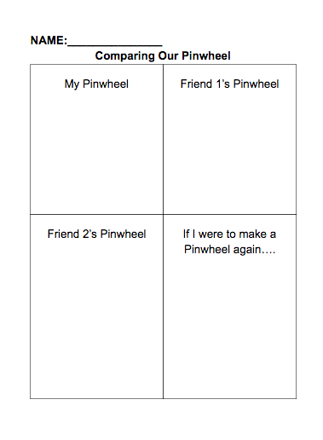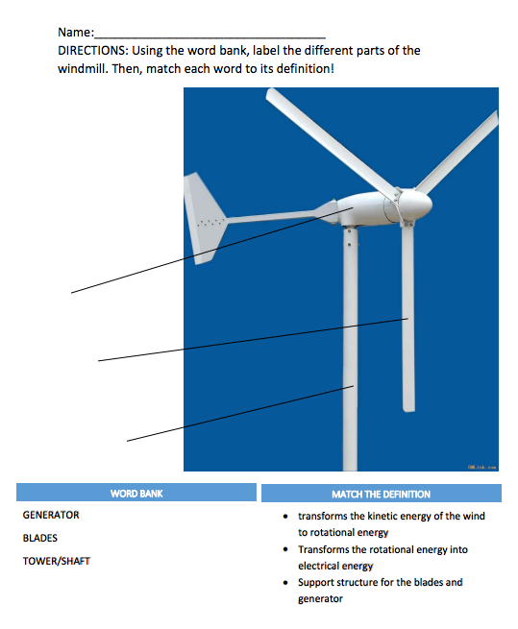

Week 4: Hydro Energy - Second and Third
A) BIG IDEA or CONCEPTS-LEARNING OBJECTIVES (3 points)
- Objectives:
  - Students will be able to demonstrate how water can be used as energy. They will do this by creating their own water turbine.
  - Students will create a dam in stations using the water tables. They will demonstrate their understanding through the class discussions as well as using KWL charts.
- Focus Question: How can water be used as a source of energy?
B) STANDARDS (4 points)

4.ESS.2 Obtain and combine information to describe that energy and fuels are derived from natural resources and their uses affect the environment.

Process Standards
SEPS.2: Developing and using models and tools
SEPS.3: Constructing and performing investigations
SEPS.6: Constructing explanations (for science) and designing solutions (for engineering)

C) MATERIALS (4 points)
- Barbeque skewer- 50
- Spool of string
- Clay, small ball per child-
- Pitchers- (5)
- Water/erosion table
- Rocks/dirt/sand for building dams
- Clipboards (13)
- Smaller Plates (50)
- Small Dixie Cups (150)
- Tape - 6 rolls
- Scissors
- Hole- punches (6)

D) TEACHER CONTENT KNOWLEDGE (4 points)

To teach this lesson the teachers need to understand the basic fundamentals of hydro energy. Hydro energy is a renewable resource, which uses water motion to create electricity. Around the world there are places such as hydropower plants, where falling water is generated usable energy (electricity) by using a turbing to transform the kinetic energy from the moving water to rotational energy. This rotational energy goes through the generator and turns into electrical energy. In addition to understanding the process the energy goes through the teacher should understand the parts of the hydroelectric plants:
- Dam - its job is to raise the water elevations of a river, by doing this we create falling water. By creating the dam we can also control the flow of water. The dam also stores the electrical energy.
- Turbine - its job is to force the falling water against the blades causing the turbine to rotated. The turbine transforms the kinetic energy into mechanical energy.
- Generator - This is connected through the shaft to the turbine. The turbine spins along with the generator. Here the turbine’s mechanical energy turns into electrical energy.
- Transmission lines - its job is to transfer the electricity to cities, towns, homes, etc.
The teacher should also know the Pros and Cons of Hydro energy. Some of the pros are:
- It is a renewable source
- It is clean and there is no pollution
- It is a safer form of energy and not entail a great hazard to people
- You can control the flow of water to control the output of energy
- Once build you have a life time investment
The cons of hydro energy are:
- Dams can cause floods, which can have strong impacts on ecosystems and wildlife.
- The building of dams require people that live in that area to relocate.
- Older dams have breaches and can result in floods and deaths.
- Dam are super expensive to build.

E) REFERENCES & HANDOUTS (2 point)
- About hydro-energy https://www.youtube.com/watch?v=tpigNNTQix8
- Water turbine how-to https://www.youtube.com/watch?v=x8xow_R0YRI
- Magic School Bus: https://www.youtube.com/watch?v=mSec3ywo0Kw
- Pros and Cons: https://netivist.org/debate/hydropower-pros-and-cons
- Information: http://www.wvic.com/content/how_hydropower_works.cfm
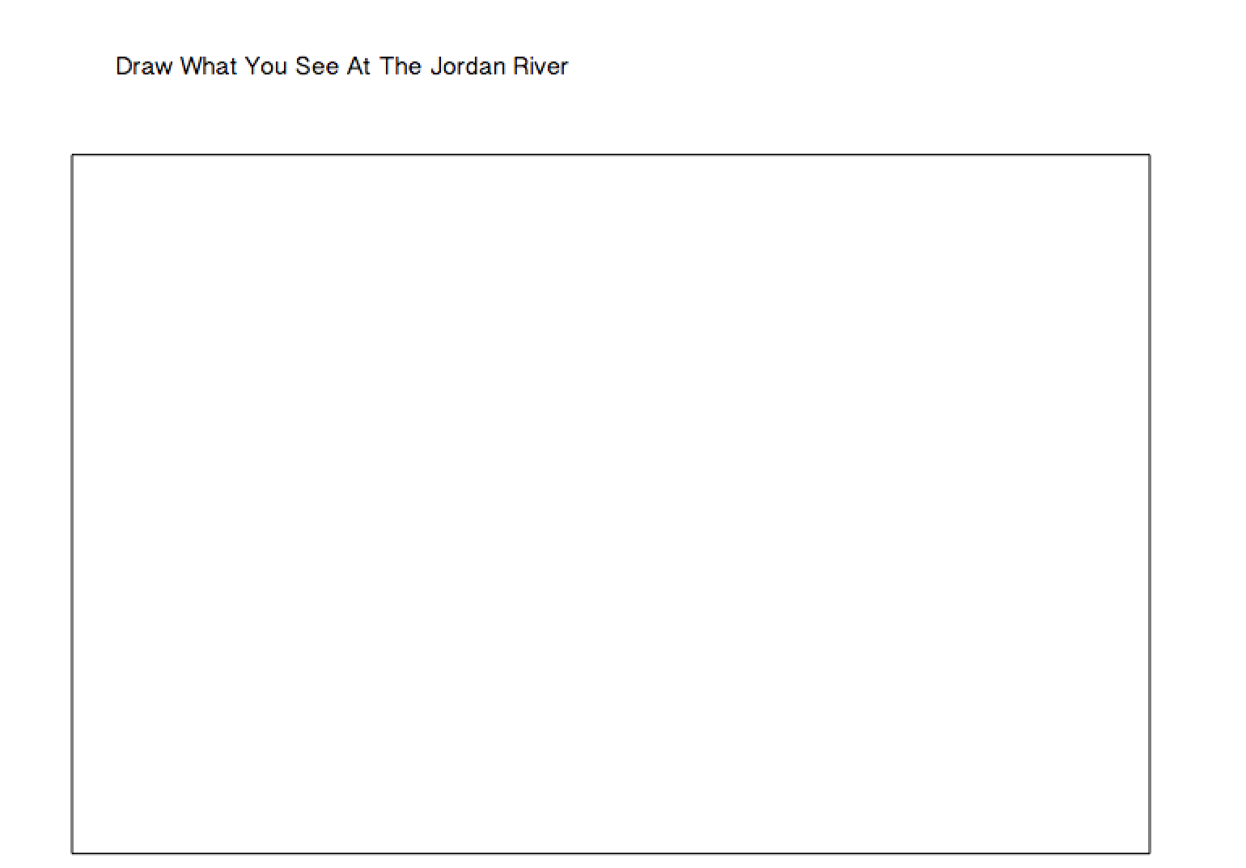

F) TENTATIVE TIMELINE (5pts)
(lead teachers will be Ike, Melissa, Alex; support teachers will be Lindsey, Shannon, Kristen)
9:30-9:35 Review previous lessons, go over forms of energy (Melissa will lead)

9:35-9:45 Introduce hydro-energy, create definition as a class (Ike will lead, Alex will be writing)

9:45-9:50 Fill out K and W sections of KWL chart on hydro energy (Alex will lead while Melissa writes)

9:50-9:55 Read aloud: Water Power by Tea Benduhn (Melissa will read)

9:55-10:00 Watch video Energy 101: Hydropower, discuss (Ike will lead) https://www.youtube.com/watch?v=tpigNNTQix8

10:00-10:40 ½ class does Water tables/dams and other ½ goes to Jordan River, observe water flowing, discuss how we could harness energy from it (Melissa, Alex, and Lindsey will stay inside to facilitate water tables- Ike, Shannon, Kristen will take students outside to dam)

10:40-11:10 Video: Magic School Bus https://youtu.be/mSec3ywo0Kw /snack/bathroom (Ike, Melissa, and Alex will lead)
- **Water turbine video: https://www.youtube.com/watch?v=x8xow_R0YRI (Melissa will lead)
- “A water turbine is much like a windmill, except the energy is provided by falling water instead of wind.”
11:10-11:45 Build water turbines individually. Test using large containers and pitchers of water. (Each teacher will have a lab table)
11:45-12:00 Clean up, wrap up by finishing KWL chart/ discussion about pros and cons (Alex, Melissa, & Ike will lead)
F) DESCRIPTION OF YOUR LESSON (8 points)

ENGAGE: Provides the opportunity for science teachers to identify students’ current science ideas; establish a context for study; motivate students.

To engage the students in this week’s lesson we will start with asking the students, “What do you already know about the renewable energy, hydro-energy?” With this we will be identifying what the students already know about the science concept of hydro-energy. Once we have filled out the K section of our on-going KWL chart we will transition into showing students a clip over hydro-energy. This video is kid friendly and introduces lots of valuable information over the concept they will be investigating. This will help establish the context of what we are investigation throughout the rest of the lesson.
FORMATIVE ASSESSMENT:
    - What do you know about hydro-energy?
    - What can we use water to power?
    - What do dams harness?

EXPLORE: Provides a common set of experiences for students; opportunities for students to clarify and test their ideas; compare their ideas with others.

For this lesson the students will be exploring the concept of hydro-energy by creating their own dam. Students will be given all the materials needed to make a dam. They will be using the water tables to construct their dam out of rocks, sand, and dirt. The students will not be given any direct instructions on how to create the dams. After the students create their dam they will pour water into the tables and using a fan to create the current in the water. They will be doing in two separate groups. While two groups of the students are creating their dames the other two will be visiting the Jordan River to explore how the water flows and transfers energy through the water. While they are at Jordan River they will be drawing a picture of what they see on a worksheet given.
Later in the lesson the students will be creating a water turbine and water wheel. Here the students will be investigating how to use the water's movement to create rotation energy with both devices. With the water turbine the students will use that rotational energy to lift the clayball. The students will be harnessing the water and using its energy, while creating their own model to take home.

FORMATIVE ASSESSMENT:
    - What qualities of your dam worked?
    - What qualities of your dam did not worked?
    - What were some difficulties you faced when making your dam?
    - What were some things you kept in mind when creating your dam?
    - What common patterns did you found when testing your tables dams?

EXPLAIN: Provides opportunities for students to use previous experiences to begin making conceptual sense of the activities; allows for the introduction of formal language, scientific terms, and content information.

In order for students to begin to understand how to construct a dam, they need to have knowledge of its functions and necessary parts. During the explain phase, students will be watching a video covering the necessary pieces in a well-functioning dam. After the video we will specifically point out and explain the parts of a dam that were pointed out in the video. In the explain phase we will also have a discussion with the students after they observe the Jordan River and the water energy in it. We will explain the path the energy takes.

FORMATIVE ASSESSMENT:
  - Probing Questions
    - How does a dam harness energy?
    - What can hydro-energy do when the water runs into the shore?
    - What are the components of a dam?

ELABORATION: Provides students the opportunity to apply or extend their thinking about the concept(s) they have learned through the explore and explain phases. This may also serve as an opportunity to incorporate some sort of summative assessment (the 5th E).

Throughout the entirety of the activities including the read-aloud, videos, and building the water turbine and dams, students will be learning a lot of new information about hydro energy. In order to extend their thinking on the basics of what hydro energy is, we want the students to be able to reason through the pros and cons of using this type of energy. To start this train of thought, we will ask students to discuss what they believe the pros and cons are of hydro energy. If there are pros/cons that were not mentioned at the beginning of the lesson, we will write them on the L section of the KWL chart. To end the lesson, we will be adding the main ideas we learned during the lesson to our “L” section as well. This will give students the opportunity to apply what they have learned to a common goal, which also allows us time to collect papers and evaluate what knowledge students have acquired throughout the morning. They will finish the day with a preview the following week, talking about how the students will be designing their own town/cars.

FORMATIVE ASSESSMENT:
- What are the pros of hydro energy?
- What are the cons of hydro energy?
- Why is hydro energy important?

G) EMBEDDED FORMATIVE ASSESSMENT (also part of the 5th “E”) (3 points)
Found in the lesson plan

H) GEARING UP/GEARING DOWN (2 point)

Gearing up – If students seem to be understanding the concept of water energy quickly, we will add on to their experiment experiences to keep them engaged. For example, when building their dams, we will challenge students to think of a second design that would use less materials but do the same work as their original design. If during their water turbine design they are way ahead, we will take a similar approach and ask them to design a new turbine that shows improvements based on their original or challenge them to use less materials to create a more ‘cost efficient’ turbine.

Gearing down – For students that may be struggling, we will have an IU student work closely with them. We can give them ideas and suggestions to continue their construction of dams and turbines. If they are not understanding the content in general, we will show students key pages from the read aloud or points from the videos for a discussion that will clarify their confusion.

Week 5: Living with Renewable Energy: 2nd and 3rd Grade
A) BIG IDEA or CONCEPTS-LEARNING OBJECTIVES (3 points)
- Objectives: Students will be able to explain the components of how energy is used in their communities by apply it to create their own diorama of an energy efficient town or specific renewable energy object (e.g. car, windmill, solar panel).
- Focus Question: How can towns use renewable energy in their neighborhoods?
B) STANDARDS (4 points)
4.ESS.2 Obtain and combine information to describe that energy and fuels are derived from natural resources and their uses affect the environment.
Process Standards
SEPS.2: Developing and using models and tools
SEPS.3: Constructing and performing investigations
SEPS.6: Constructing explanations (for science) and designing solutions (for engineering)
C) MATERIALS (4 points)
Clipboards (25)
Anything and everything for creating dioramas:
Construction Paper
Markers
Pipe cleaners
Straws
Lots of Various Size Cups
Various Size paper plates
Small Paper Clips
*Pushpins
*Hot glue gun
Pom poms
Shoe Boxes and Solar Oven Boxes (27)
Foam piece
Balloons
Small pebbles
Dirt
Cardboard
Foil
Beads
Scissors
Glue sticks
Elmer's glue
Masking Tape- as many as you can give us
*the teachers will be passing out the push pins and they will be used to poke holes in the windmills, or cardboard
*The teachers will be the ones operating the hot glue guns and the students will come up to us and we will glue what they want

D) TEACHER CONTENT KNOWLEDGE (4 points)
The final week will be a compilation of the knowledge teachers have needed in the previous weeks. Students will be using what they have learned to build their own renewable energy-based towns, products, inventions, etc., therefore the teachers will need to understand each type of energy and how it can be harnessed in these ways. They will need to know:
- the different types of energy (e.g. sound, light, heat, nonrenewable, renewable), how we get them, and what are alternatives to nonrenewable
- The definitions: Renewable energy- energy that can continuously be harnessed as a source of electricity, power, etc.; Nonrenewable energy- energy that cannot be reused as a source of electricity, power, etc. once it has been used up; Solar Energy- energy harnessed from the heat and light of the sun; Wind Energy - kinetic energy from the wind is converted into mechanical energy and then finally into electrical energy (Wind turns the blade =>rotates the parts inside the body of the turbine => rotates the generator => electricity); Hydro energy - is a renewable resource, which uses water motion to create electricity.
- Types of tools/machines that are involved in each type of renewable energy sources and how they work (water wheels, windmills, solar panels, generators, blades, etc.)
E) REFERENCES & HANDOUTS (2 point)
- Scavenger Hunt handout:
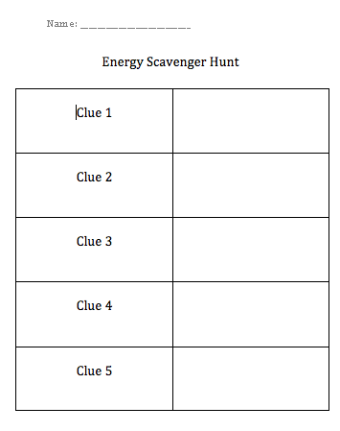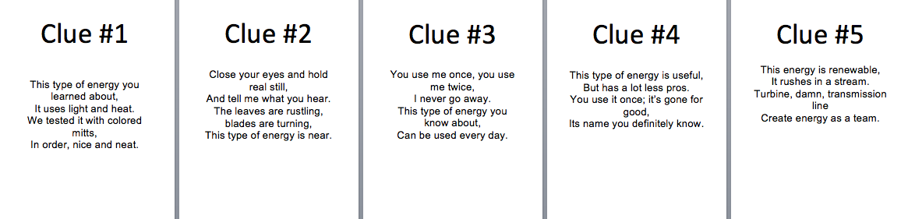

F) TENTATIVE TIMELINE (5pts)
9:30-9:35 Review all we’ve learned so far- Shannon, Lindsey, and Kristen will lead this
9:35-10:00 Energy Scavenger Hunt- each teacher will have a group of students (all lead)
10:00-10:20 Snack outside and bathroom break
10:20-11:40 Students will create their Ideal Towns or Inventions- all teachers have a lab table
- Go through the different types of renewable energy they must use at least one
11:40-11:50 Clean up
11:50-12:00 Show off dioramas to parents and classmates
F) DESCRIPTION OF YOUR LESSON (8 points)

ENGAGE: Provides the opportunity for science teachers to identify students’ current science ideas; establish a context for study; motivate students.

To engage the students with this lesson we will begin with the Energy Scavenger Hunt. For the scavenger hunt we will give each student a chart and work in their lab table teams to find the five landmarks around the School of Education. The marks will contain the definitions of renewable energy, non-renewable energy, solar energy, wind energy, and hydro energy. The students will find each marker and as a group decide which ‘vocab’ word belongs with the marker. This will engage the students because it will get them thinking about what types of energy they have been learning all about. They can then use this information for when they create their ideal town.

FORMATIVE ASSESSMENT:
- What are some forms of renewable energy that can be found in an ordinary neighborhood?
- What forms of renewable energy are not found in this neighborhood and why do you think that is?
- What are some ideas of ways to incorporate renewable energy into your neighborhood?
EXPLORE: Provides a common set of experiences for students; opportunities for students to clarify and test their ideas; compare their ideas with others.

The students will explore in this lesson by doing the Ideal Town activity. In this activity the students will be shown a couple examples about what an “ideal town” could look like that the teachers created. The students will then get to chose what to build their ideal town out of from a bunch of random materials we will provide them with. The students can decide what they want their towns and inventions to look like without guidance. The only requirement for the Ideal Town activity is that the students have to include at least one renewable energy source in the towns or inventions. This activity will allow the students to explore because they will be able to apply their knowledge they have gained about renewable energy, throughout the weeks, and see how they can actually work within a town.

FORMATIVE ASSESSMENT:
- What forms of energy did you chose to include in your ideal town and inventions and why?
- What forms of energy did you not chose to include in your ideal town and inventions and why?
- Do you think a town and inventions could function solely on renewable energy? Why or why not?

EXPLAIN: Provides opportunities for students to use previous experiences to begin making conceptual sense of the activities; allows for the introduction of formal language, scientific terms, and content information.

In order for the students to understand how to build their Ideal Towns or Inventions we will refer back to the Energy Scavenger Hunt and the read aloud. The Energy Scavenger Hunt will help the students remember the definitions of energy sources. Also, the read aloud will help to explain how renewable energy can be found in towns. This is true because the students will gain more knowledge about how the content of renewable energy can once again be found in towns. This will once again help them build their towns.

FORMATIVE ASSESSMENT:
- How can renewable energy function in a town?
- What ways can you add the resources that you saw in the scavenger hunt to your town?
- What ways can we add renewable energy resources to our town to increase renewable energy in Bloomington?

ELABORATION: Provides students the opportunity to apply or extend their thinking about the concept(s) they have learned through the explore and explain phases. This may also serve as an opportunity to incorporate some sort of summative assessment (the 5th E).

During the explore phase of the lesson we had the students create an Ideal Town diorama or an Invention. For the elaboration phase of this lesson the students will be able to present and explain their dioramas that they created to other students and also their parents. By doing this the students will be given the opportunity to apply or extend their thinking about the concepts that they learned in the earlier phases because they will be the ones explaining what they created and how the sources of energy that they chose to incorporate are renewable. They will also elaborate on the knowledge that they learned throughout the past four weeks by creating the Ideal Towns and then discussing them with others.

FORMATIVE ASSESSMENT:
- How does your town incorporate the different renewable energy that we have discussed?
- How can you explain the elements of your ideal town to others?
- What aspects of your ideal town have you seen in an actual town and how do they work?

G) EMBEDDED FORMATIVE ASSESSMENT (also part of the 5th “E”) (3 points)
Found in the lesson plan.

H) GEARING UP/GEARING DOWN (2 point)
Gearing up – If students seem to be flying through the Energy Scavenger Hunt the headteacher will take their group to the amphitheater for a critical thinking discussion. Here the teacher will ask the students the follow questions:
- Living in Bloomington, what types of renewable energy would be the best to use? Why?
- How would you harness these types of renewable energy sources?
- What devices, tools, machines, etc. do you think could be built to capture the most of each type of energy?
If students need to be challenged during the Ideal Town or Invention teachers will challenge the students to use a different type of renewable energy in their town or invention. Teachers can also challenge the students to use less materials, create more landforms or details to their town or inventions (e.g. decorating).

Gearing down – For students that may be struggling, we will have an IU student work closely with them. We can give them ideas and suggestions to continue their construction of the towns or inventions and how they can use renewable energy sources with these products. If they are not understanding the content in general, we will get the students to think back to the last several classes. The teachers will remind the students of the information they learned from the scavenger hunt as well as the products they create for the solar, wind, and hydro lessons.

